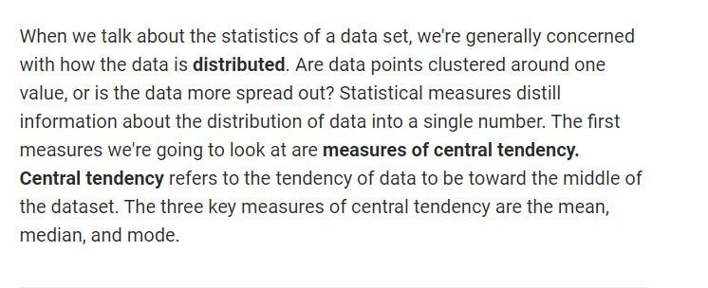

Very Important Factoid about Skewness you will never get right:

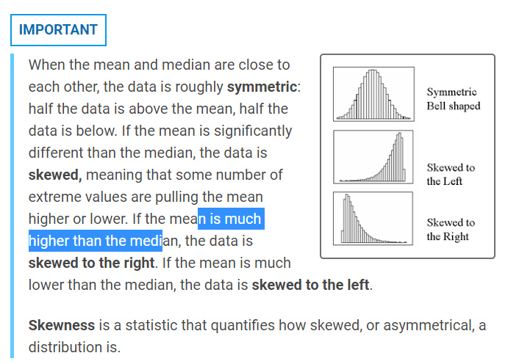

<https://www.statisticshowto.com/probability-and-statistics/skewed-distribution/>

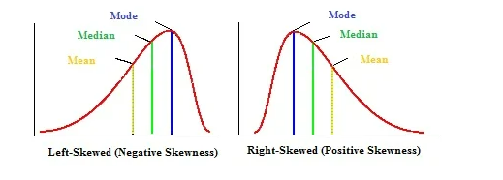

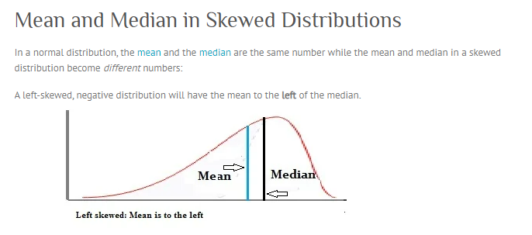

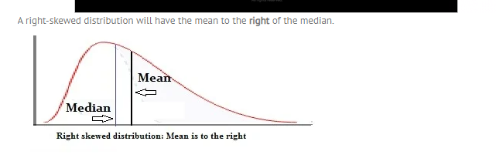

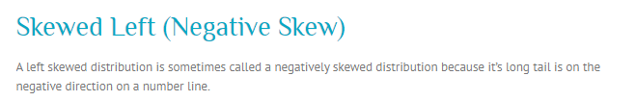

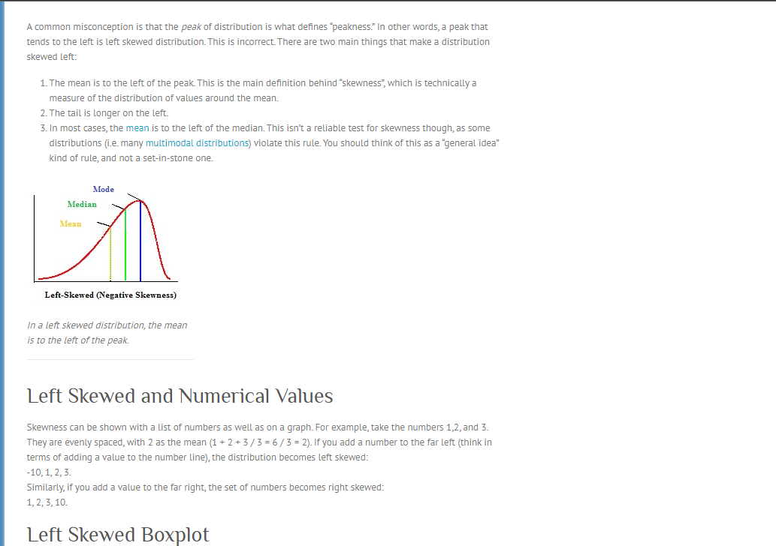

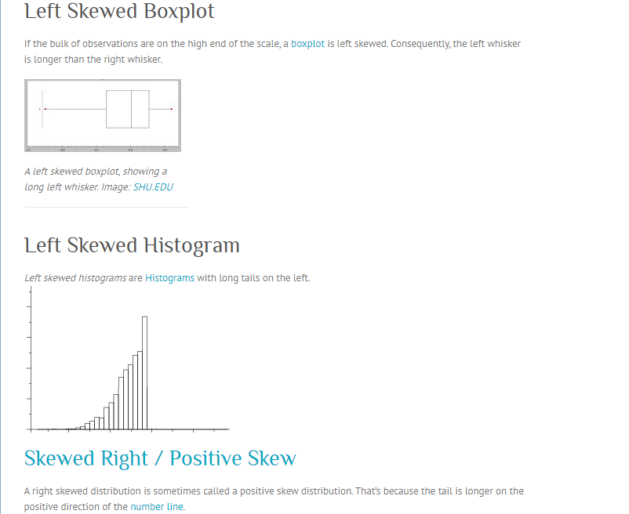

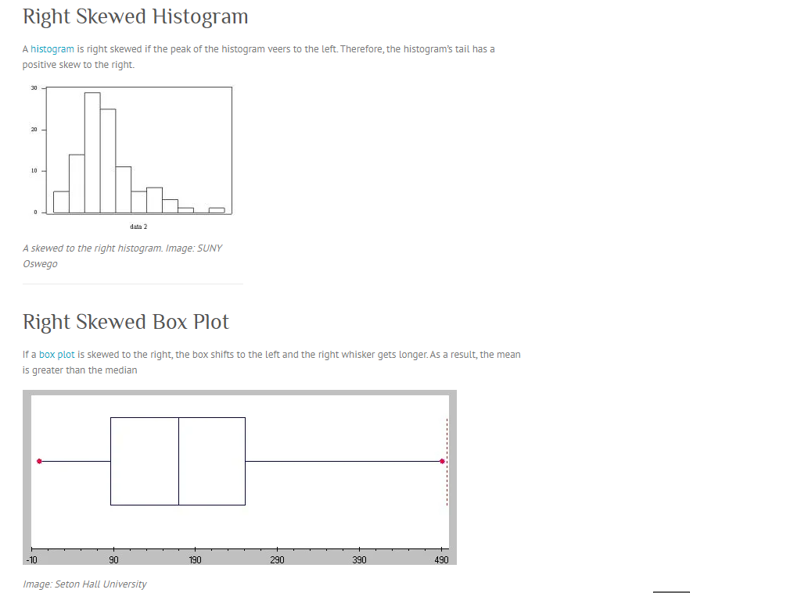

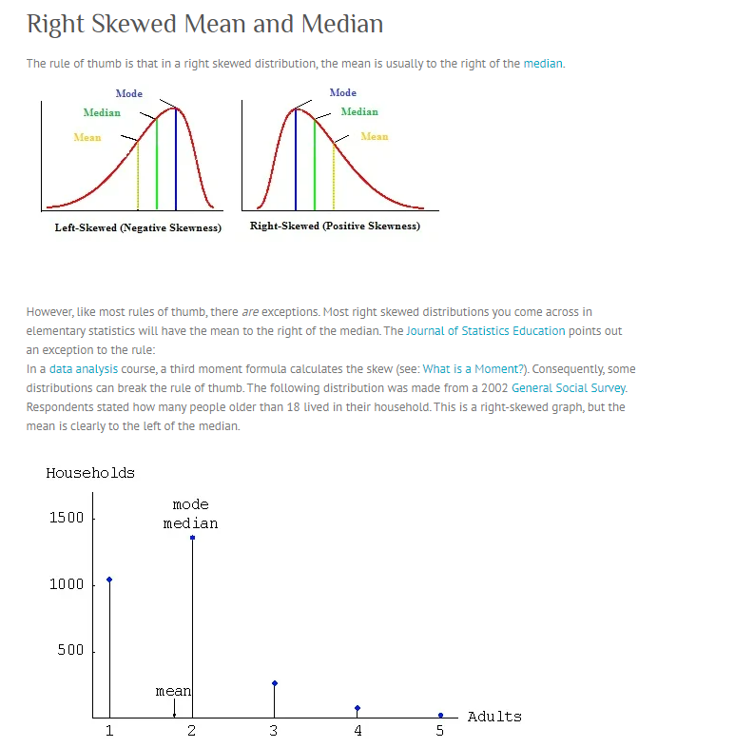

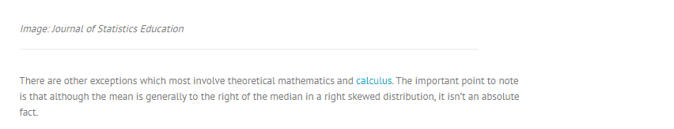

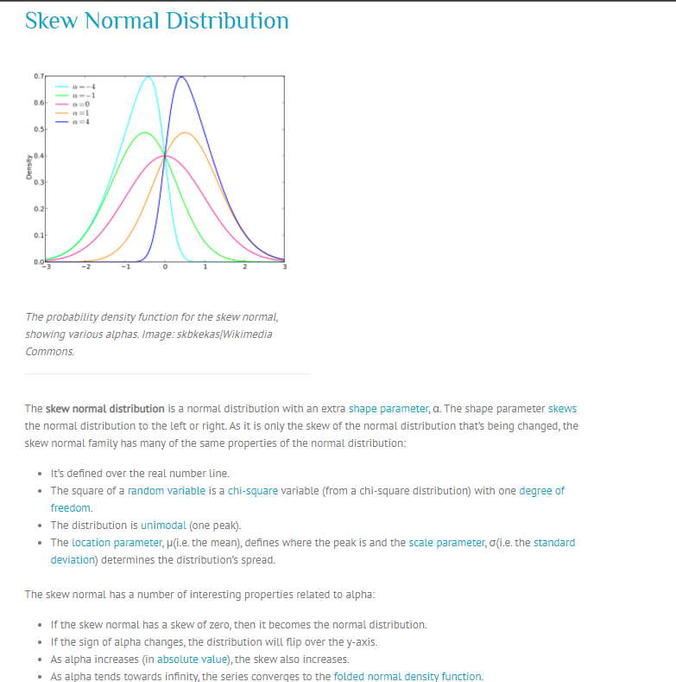

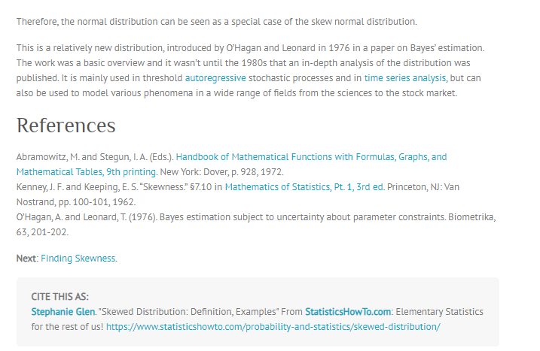

---------------------------------

**standard deviation and variance**

When considering the distribution of a dataset, we also want to have measures of its spread. **Measures of spread** include range, variance, standard deviation, and quartiles.

**Range**

The simplest measure of spread is the range of a dataset. The **range** is the difference between the maximum value of the dataset and the minimum value of the dataset. For our purposes, the range does not capture as much information as we'd like. What we would really like to know is roughly how far each data point is from the center, or mean, or how much of the data is near the center.

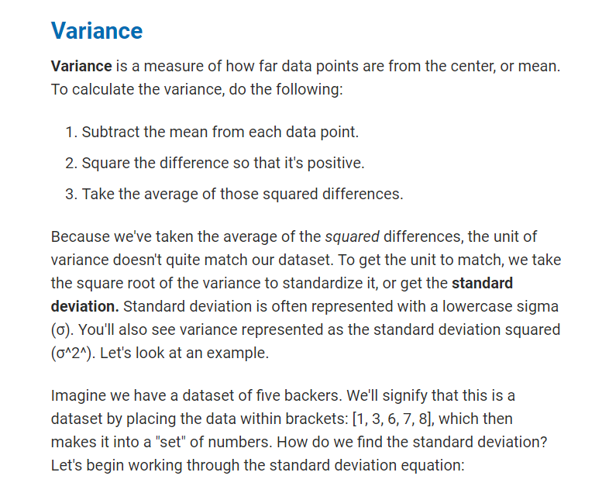

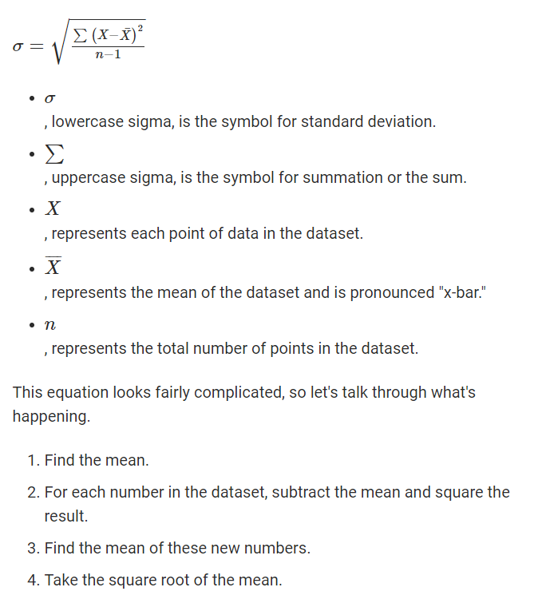

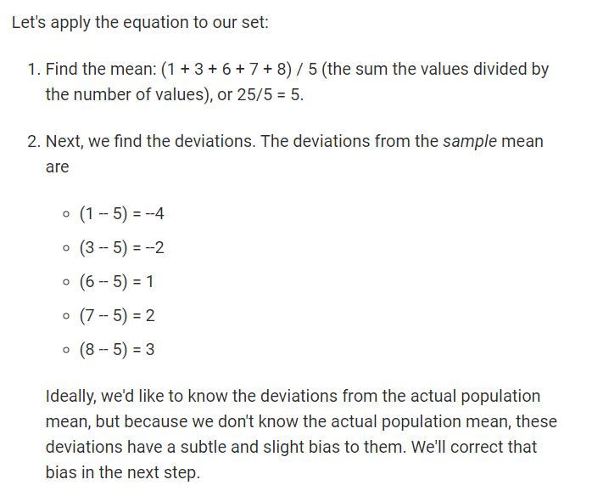

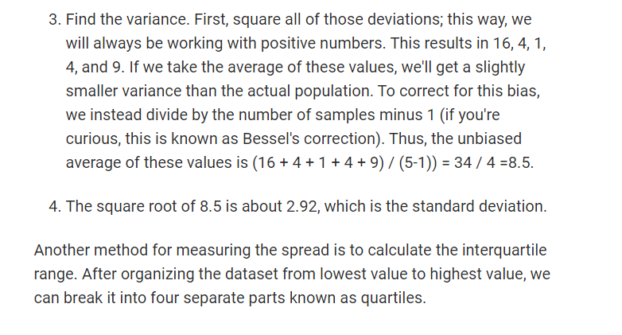

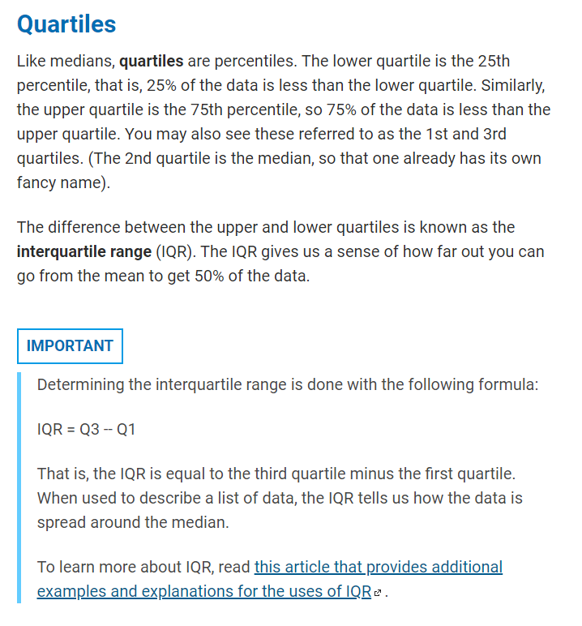

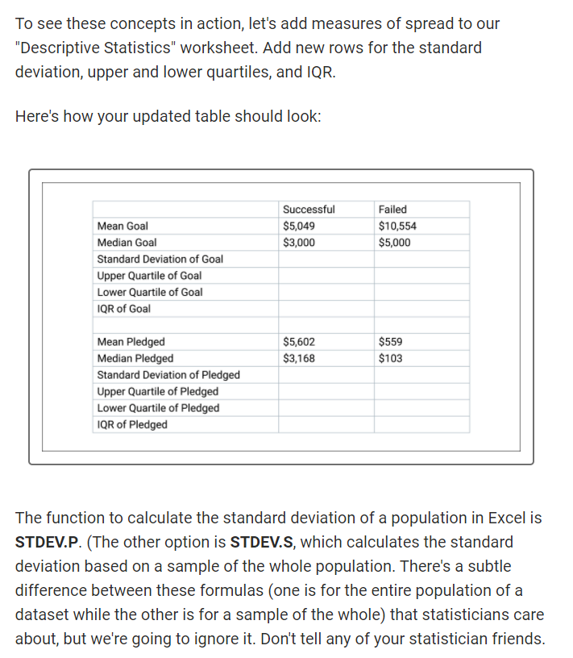

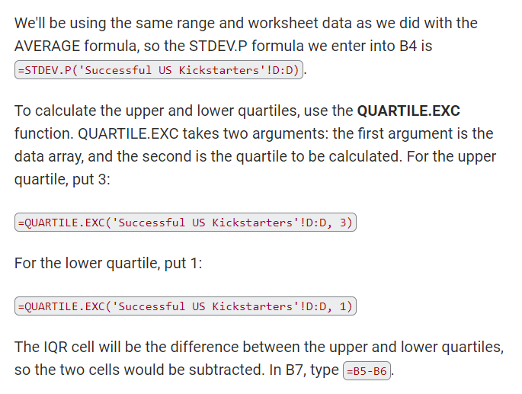

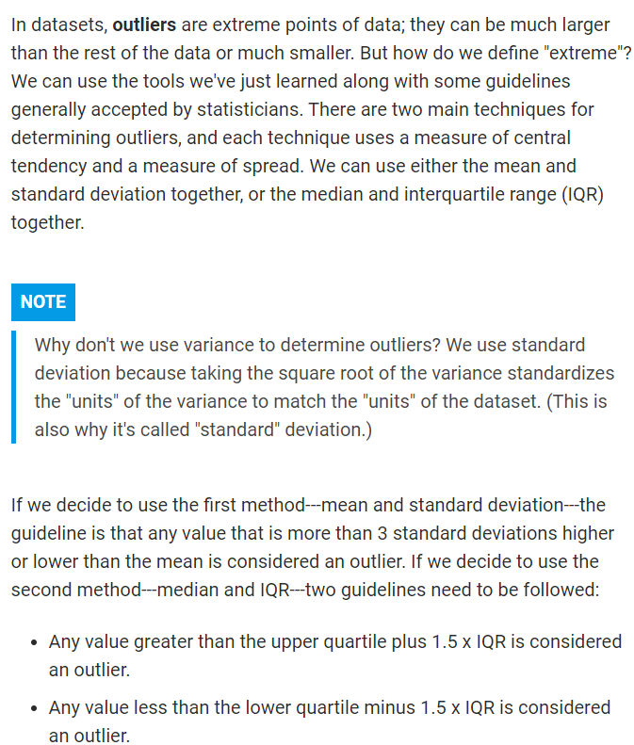

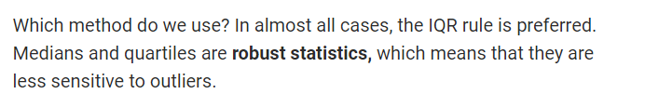

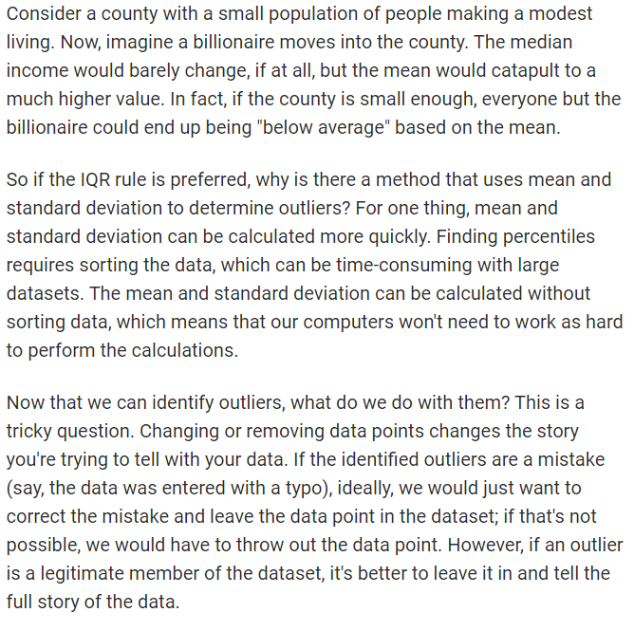

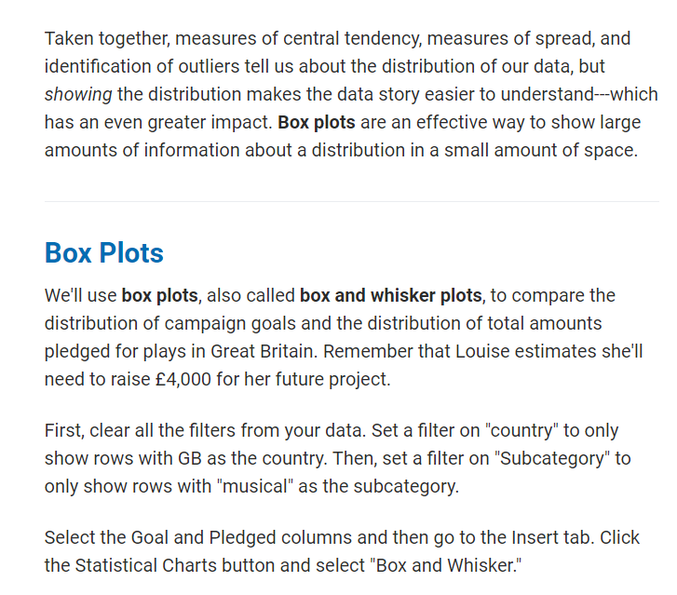

Now move the chart to its own sheet by going to the Design tab and selecting the Move Chart button.

* The box shows the interquartile range with a line for the median and an "X" to indicate the mean.
* The whiskers show the extreme values within 1.5 times the interquartile range.
* Outliers are represented by labeled dots.

